**Ideation Phase**

**Define the Problem Statements**

|  |  |
| --- | --- |
| Date | 18th June 2025 |
| Team ID | LTVIP2025TMID20428 |
| Project Name | FlightFinder |
| Mentor Name | Dr Shaik Salma Begam |
| Maximum Marks | 2 Marks |

**Customer Problem Statement Template:**

Create a problem statement to understand your customer's point of view. The Customer Problem Statement template helps you focus on what matters to create experiences people will love.

A well-articulated customer problem statement allows you and your team to find the ideal solution for the challenges your customers face. Throughout the process, you’ll also be able to empathize with your customers, which helps you better understand how they perceive your product or service.

Reference: <https://miro.com/templates/customer-problem-statement/>

**Example:**

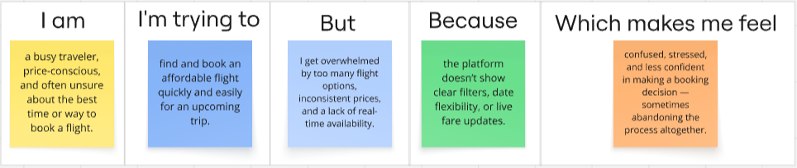

| **PS No.** | **I am (Customer)** | **I’m trying to** | **But** | **Because** | **Which makes me feel** |
| --- | --- | --- | --- | --- | --- |
| **PS-1** | a budget-conscious traveler | find the cheapest flight options | prices change frequently and aren't updated in real-time | current platforms don’t notify price drops effectively | anxious and unsure about when to book |
| **PS-2** | a business professional | book a quick flight with minimal layovers | the filters are not intuitive | the interface lacks smart suggestions based on my past travel patterns | frustrated and delayed in decision-making |
| **PS-3** | a student planning an international trip | understand visa rules, baggage policies, and fare types | the information is spread across multiple airline websites | the booking platform doesn't consolidate all critical details | confused and afraid of making costly mistakes |
| **PS-4** | a parent booking flights for family vacations | compare multiple airlines and seating options | each airline has different policies and pricing schemes | there's no unified comparison view with family-friendly filters | overwhelmed and hesitant to confirm bookings |
| **PS-5** | a last-minute traveler | book an urgent flight ticket | the app takes too long to load and doesn’t show real-time seat availability | many apps aren’t optimized for performance under pressure | panicked and dissatisfied with the booking experience |